Soil classification

The natural soil consists usually of a mixture of sand, silt and clay. If a soil contains mostly sand and some clay then we would call it clayey sand. There exists an international texture classification that refers to the descriptive names of the soil. In this classification the descriptive names refer to a percentage composition with the following size limitations:

Sand 2.0 to 0.06 mm diameter

Silt 0.06 to 0.002 mm diameter
Clay smaller than 0.002 mm diameter
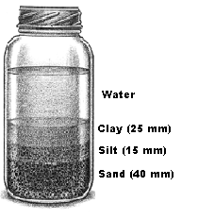
The find the percentage distribution of sand, silt and clay a soil sample from the site should be taken. Fill a container with water and add the soil sample to it. Shake the container vigorously and leave it standing until the soil particles have settled. Then measure the layer thickness of each layer as shown in Figure 1. All layers add up to 80 mm. We find the percentage of the different layers by dividing the single layer thickness by the total thickness of all layers (that is 80 mm.). The percentages are shown below.

Figure 1

Percentage of clay = 25/80 = 31.25 %

Percentage of silt = 15/80 = 18.75 %

Percentage of sand = 40/80 = 50.00 %

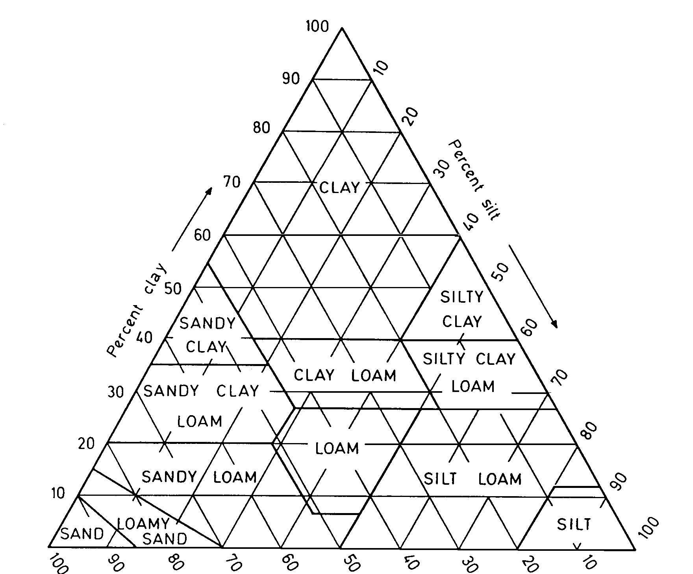
The textural classification chart is shown in Figure 2. The classification can now quickly worked out as shown in the diagram

Figure 2

